**CMSC204**

**Assignment #6**

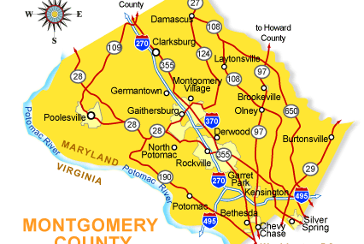

Behind every Google Map, there is a much more complex structure that's the key to your queries but hidden from your view. It contains the logic of places: their no-left-turns and freeway on-ramps, speed limits and traffic conditions. This is the data that you're drawing from when you ask Google to navigate you from point A to point B.

**Assignment Description**

In this project you will be creating an application to maintain a network of towns and the roads connecting them. The application will use Dijkstra’s Shortest Path algorithm to find the shortest distance between any two towns.

**Academic Honesty Policy** – **Do your own work.** Each project submission will be compared against other submissions from current and previous semesters.

**Good Faith Attempt (GFA) Requirement –** Your submission must successfully pass all of the provided (public) Junit test cases. In general, they are the xyz_test.java and xyz_GFA_test.java files (where xyz is the project name).

**Expectations**

* **INCLUDE your name as the author** on every Java file that you are creating

**Concepts tested by this assignment**

Implement Graph Interface

Use Graph to maintain a network of Vertices

Implement Shortest Path Algorithm

**Classes**

**Data Element – Town (Vertex)**

Create a Town class that holds the name of the town and a list of adjacent towns, and other fields as desired, and the traditional methods (constructors, getters/setters, toString, etc.). It will implement the Comparable interface. This is the class header:

public class Town implements Comparable<Town>

Two towns will be considered the same if their name is the same.

**Data Element – Road (Edge)**

Create a class Road that can represent the edges of a Graph of Towns. The class must implement Comparable. The class stores references to the two vertices(Town endpoints), the distance between vertices, and a name, and the traditional methods (constructors, getters/setters, toString, etc.), and a compareTo, which compares two Road objects. Since this is an undirected graph, an edge from A to B is equal to an edge from B to A. This is the class header:

public class Road implements Comparable<Road>

**Data Structure – Graph, implements GraphInterface**

Create a Graph class that implements the GraphInterface given you. For Graph<V,E>, V is the vertex type (a Town), E is the edge type (a Road). You will need to decide how to store the graph, use an adjacent matrix or an adjacency list. This is the class header:

public class Graph implements GraphInterface<Town, Road>

Within the Graph interface is a method shortestPath, which finds the shortest path from a given source Town to a destination Town. Since there is a unique shortest path from every vertex to the source, there is a back-pointer to the previous vertex. The method shortestPath calls dijkstraShortestPath which finds the shortest path from the source to every other vertex in the graph. You will be coding the Dijkstra’s Shortest Path algorithm. You will then be able to find the connections between two towns through the roads that connect them.

You may use the adjacency matrix approach found in the text book, or you may use a set of Towns and a set of Roads. The ShortestPath algorithm typically uses a weighted graph which means that the edges have a weight, and this is used to determine the shortest path. For this implementation, each weight will be the distance of the road in miles.

**Data Manager – implements TownGraphManagerInterface**

Your TownGraphManager will hold an object of your Graph. Implement the TownGraphManagerInterface. There are methods to populate the graph (reading from a text file), add a town (vertices), add a road (edge), list all towns and all roads, and list towns adjacent to a given town.

Your solution will find the shortest path from a start town to a destination town. It will account for the possibility of a disjoint graph (i.e., not all vertices can be reached from all other vertices.)

You may add any methods as needed for your design.

**Exception Classes**

FileNotFoundException – created and thrown when the selected input file is not found.

IOException – created and thrown when user selects an input file that cannot be read (check out the methods of File).

These exceptions exist in the Java API.

**GUI Driver (provided for you)**

The GUI has four sections: a Town section where you can add towns, a Road section where you add roads, a Find Connection section, and an administration section. It has a Read File button, which allows the text files provided to be read and populate the graph.

**Testing**

1. Your completed implementation must pass the TownGraphManagerTest.java and the GraphTest.java.
2. The tests marked GFA (“Good Faith Attempt”) are the minimal testing that must pass in order for your implementation to meet the good faith attempt.
3. Create a JUnit Test - TownGraphManager_STUDENT_Test. Test all the methods of the TownGraphManager with a different set of data than the TownGraphManagerTest provided for you.
4. Create a JUnit Test – Graph_STUDENT_Test. Test all the methods of the Graph with a different set of data than the GraphTest provided for you.
5. Create a Junit Test – Road_STUDENT_Test. Test all the methods of your Road class.
6. Create a Junit test – Town_STUDENT_Test. Test all the methods of your Town class.
7. Test your project with a minimum of 4 test cases to ensure that your project is working correctly.
8. Capture your test runs (actual vs. expected results) in your write-up to indicate that you have tested your project). A 28% deduction will be imposed to any project that did not include student test cases and their respective test results

**Assignment Details**

**Populating the Data Structure**

You will be reading from a data file. You are provided with two sample files: MD Towns.txt and US Towns.txt along with two PowerPoint slides showing these graphs.

The Towns.txt files hold the information for the individual Towns and Roads, and is in the following format:

road-name,miles;town-name; town-name

For example:

I-94,282;Chicago;Detroit

Notice that the road-name and miles are separated by a comma, while the road information and the two towns are separated by semi-colons.

After reading these files, you will have an initial set of vertices and edges in your Graph.

**Examples**

**After reading in the MD Town file After reading in the US Town file**

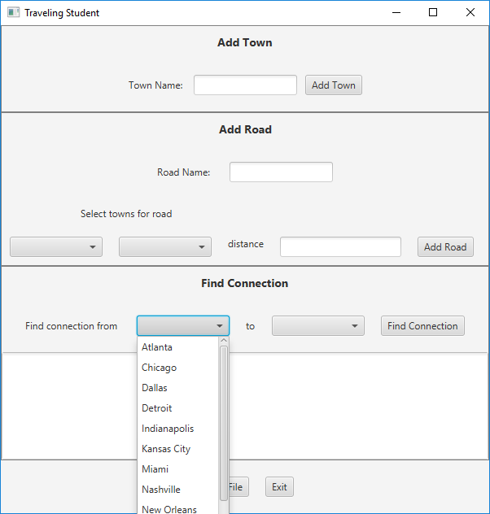

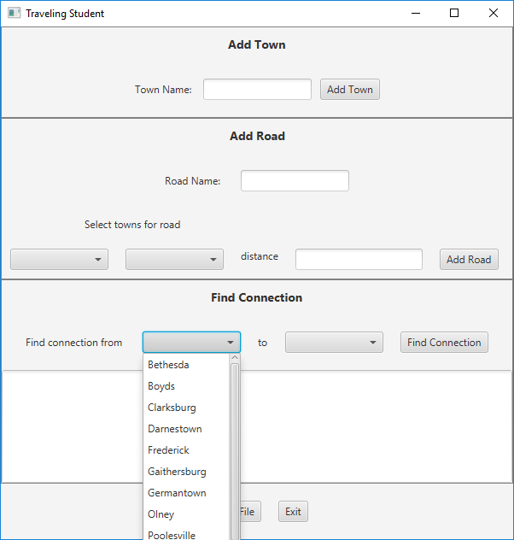

**The GUI (Provided for you)**

The GUI will have four sections: an Add Town section, an Add Road section, a Find Connection section, and an administration section. There will be four ComboBoxes each containing the same list of Towns. On startup the graph will be empty.

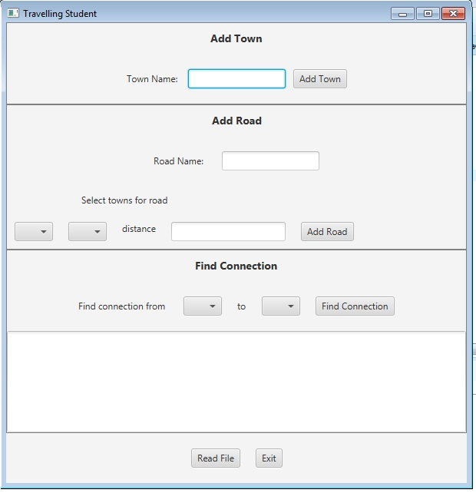

**Add a Town Button**

The user may add a new Town by typing its name in the textfield. If the textfield is blank when the Add Town button is selected, the GUI should show an error message. When a new Town is added, the TownGraphManager will add it to the graph, and the Town’s name will be added to the four ComboBoxes.

**Add a Road Button**

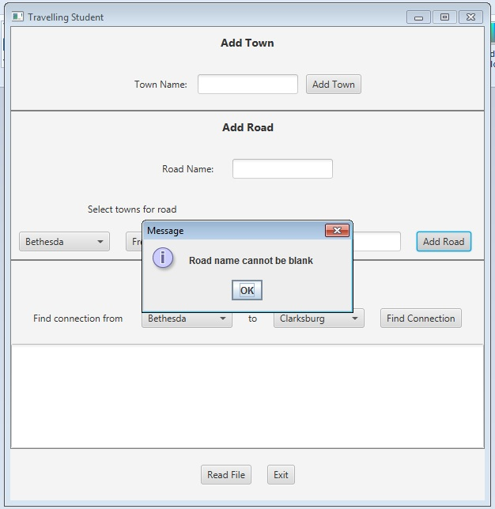To add a road, a town must be selected from each of the two ComboBoxes in the Add Road section, an integer distance entered, and a road name entered. When the Add Road button is selected, the edge is created and entered in the graph.

**Find Connection Button**

Display all the available towns in the ComboBoxes (in alpha order by name). When the user selects the towns, display the name in the ComboBoxes. When the user selects the “Find Connection” button, the TownGraphManager’s shortestPath method is called. The resulting list of roads connecting towns, and the distance along each road, is displayed in the text area.

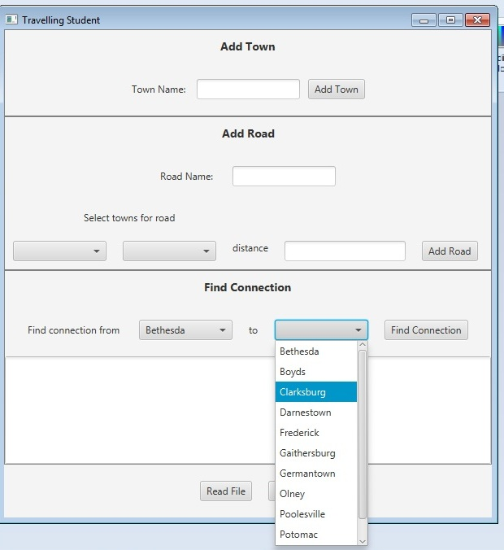

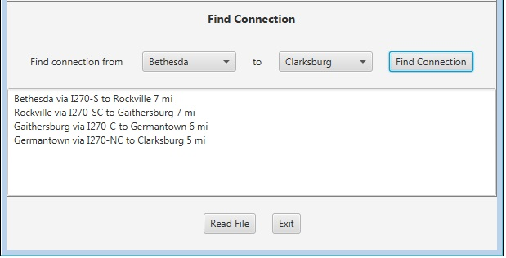

If the “source” town and “destination” town are the same, or if there is no route between the two, state that in the text area.

**Read File Button**

The Towns.txt files hold information for individual Towns and Roads, and is in the following format:

road-name**,**miles**;**town-name**;**town-name

For example:

I-94,282;Chicago;Detroit

Notice that the road-name and miles are separated by a comma, while the road information and the two towns are separated by semi-colons.

**Exit Button**

The program will terminate.

**Deliverables**

Review the provided rubric to understand project expectations, including documentation, CMSC204, and programming requirements. Two artifacts MUST be submitted for this project: Java source code and a write-up.

At a minimum, the write-up needs to address -

* Approach, design & algorithm
  + **DO NOT** start coding your project immediately! Come up with a high level design for the project first
    - What’s your game plan to complete the project?
    - Break the project into smallest modules where applicable
    - UML diagrams will go a long way
  + Each student is welcome to expand on the design, if it makes sense. Students will not be penalized for going “above and beyond” specifications of the project
  + **Complete this step first, then write your code**
* Test Plan & Test Cases
  + Ensure that your project can successfully pass all provided “public test cases.” What other test cases have you attempted?
    - Students should think about potential private tests – what would they be?
  + **Your instructor will test your project using an additional set of private test cases as well as the provided public test cases**
  + I want to see your “thinking,” in particular, how you are testing your program
  + Each submission should be rock solid, with no bugs
  + Capture screenshots of your test runs in your write-up as you run them
* Highlight your learning experience and lessons learned
  + **I am very interested to learn about what you have done, how you did, etc.**
* Anything else that you want to share with me
* Take a screen shot of the repo with the directory and files
* If your project is not working as expected, **submit it as-is but clearly articulate your situation in your write-up in order to potentially receive partial credit**

Each student must submit one compressed (.zip) file back to the Assignment (link) with the following deliverables:

* Your entire Eclipse project folder (Source code included)
* Write-up as a Word or PDF file, one write-up per project
* **I WILL compile, run and test every submission using a set of public and private test cases – this is how I test to ensure that your project is working correctly**
* Name the compressed file (zip format) as <lastname>_project_x
  + where x is the project number and your last name (e.g. Thai_Project_1.zip)
* Double check your submission, as I can only grade what’s being submitted (don’t assume anything)
* DO NOT email your submission! It won’t be accepted

**Not clear? That’s okay, but do ask your questions. “I did not know” or “I did not understand” is not good enough.**